IT1060 – Software Process Modeling 2022 - July

# Assignment 2 Cover Sheet

|  |  |
| --- | --- |
| **CASE STUDY NAME** | Online Teacher trainer |
| **PROJECT ID** | MLB 02.01.12 |

Group Details:

|  |  |  |
| --- | --- | --- |
|  | **Student Registration Number** | **Student Name** |
| **1** | IT21819506 | V.Abilaxshan |
| **2** | IT21828898 | S.Thusithan |
| **3** | IT21598500 | Abiramy.k |
| **4** | IT21809460 | M.Lavanya |

IT1060 – Software Process Modeling 2022 - July

# Assignment 2 Certify Sheet



I hereby certify,

The attached is my own work and no further changes will be made. I have contributed in this assignment to the best of my ability.

And I understand,

I may be subject to student discipline processes in the event of an act of academic misconduct by me including an act of plagiarism or cheating.

Student Details:

|  |  |  |  |
| --- | --- | --- | --- |
| **Student Name** | **Student Registration** | **Date** | **Signature** |
| **Number** |
| V.Abilaxshan | IT21819506 | 04.11.2022 | V.Abilaxshan |

**Part 1**

**Abilaxshan IT21819506**

|  |  |
| --- | --- |
| Number | OTT1 |
| Name | admin |
| Summary | publish courses |
| Priority | 5 |
| Pre-condition | admin needs to login his/her document |
| Post-condition | admin can check the update details in the system |
| Primary Actor | Admin |
| Main Scenario | |  |  | | --- | --- | | Step | Action | | 1 | search the online teacher trainer web site | | 2 | sign in as admin | | 3 | Create courses | | 4 | Add the courses | | 5 | Check the course details | | 6 | Publish the course details | | 7 | sign out as admin | |
| Extension | |  |  | | --- | --- | | Step | Branching Action | | 2a | Log in to the system using username and password | | 2b | Reset the password if it forgot and log in again to the system. | | 5a | If the courses are not accurate correct the course details. | | 5b | after correction publish the courses | |

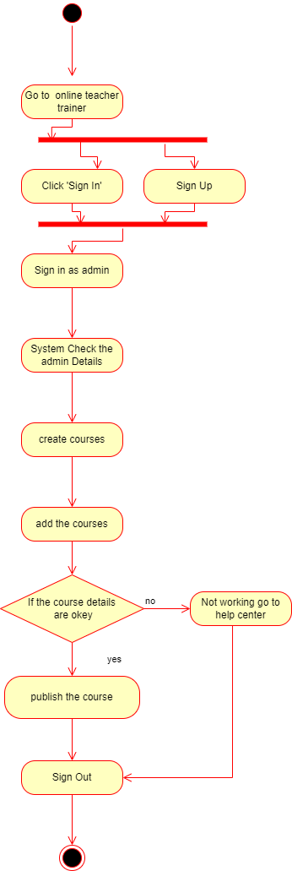

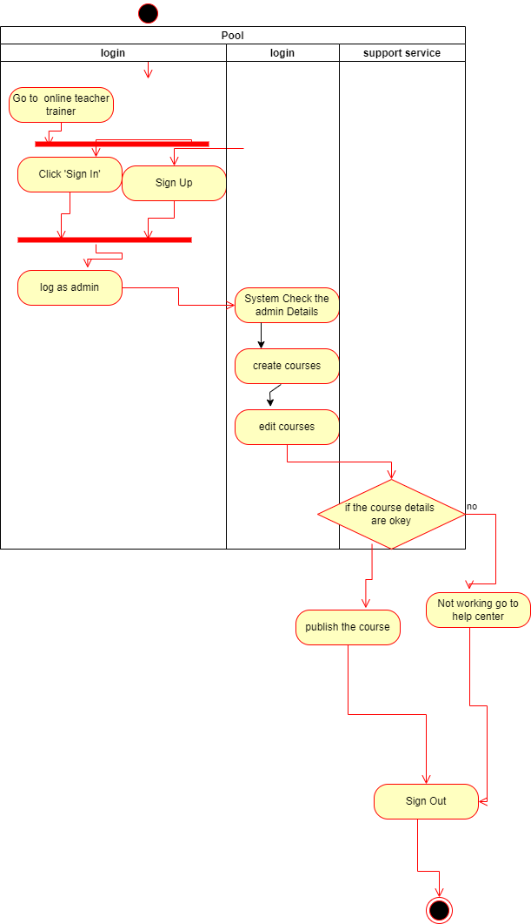

# Assignment 2 Cover Sheet

|  |  |
| --- | --- |
| **CASE STUDY NAME** | Online Teacher trainer |
| **PROJECT ID** | MLB 02.01.12 |

Group Details:

|  |  |  |
| --- | --- | --- |
|  | **Student Registration Number** | **Student Name** |
| **1** | IT21819506 | V.Abilaxshan |
| **2** | IT21828898 | S.Thusithan |
| **3** | IT21598500 | Abiramy.k |
| **4** | IT21809460 | M.Lavanya |

IT1060 – Software Process Modeling 2022 - July

# Assignment 2 Certify Sheet



I hereby certify,

The attached is my own work and no further changes will be made. I have contributed in this assignment to the best of my ability.

And I understand,

I may be subject to student discipline processes in the event of an act of academic misconduct by me including an act of plagiarism or cheating.

Student Details:

|  |  |  |  |
| --- | --- | --- | --- |
| **Student Name** | **Student Registration** | **Date** | **Signature** |
| **Number** |
| S.Thusithan | IT21828898 | 04.11.2022 | S.Thusithan |

|  |  |
| --- | --- |
| Number | OTT 3 |
| Name | Lecturer |
| Summary | Add the videos |
| Priority | 3 |
| Pre-condition | Lecturer needs to sign in his or her account |
| Post-condition | Lecturer can check the lecture videos and suggestions |
| primary Actor | Lecturer |
| Main Scenario | |  |  | | --- | --- | | Step | Action | | 1 | Go to the Online Teacher Trainer | | 2 | Click on ‘sign in’ icon on the web page | | 3 | Sign in as Lecturer | | 4 | System check the Lecturer account details | | 5 | Lecturer upload the videos and tutorials | | 6 | Lecturer can check the videos which are uploaded | | 7 | Lecturer check the suggestions of the teachers | | 8 | Sign out as Lecturer | |
| Extension | |  |  | | --- | --- | | Step | Branching Action | | 5a | If lecture videos are not working then go to help center | |

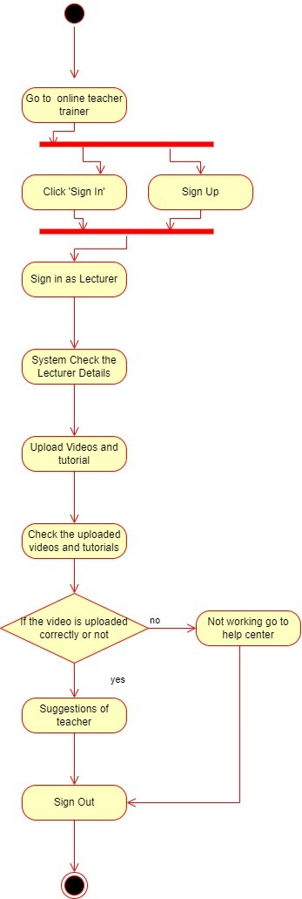

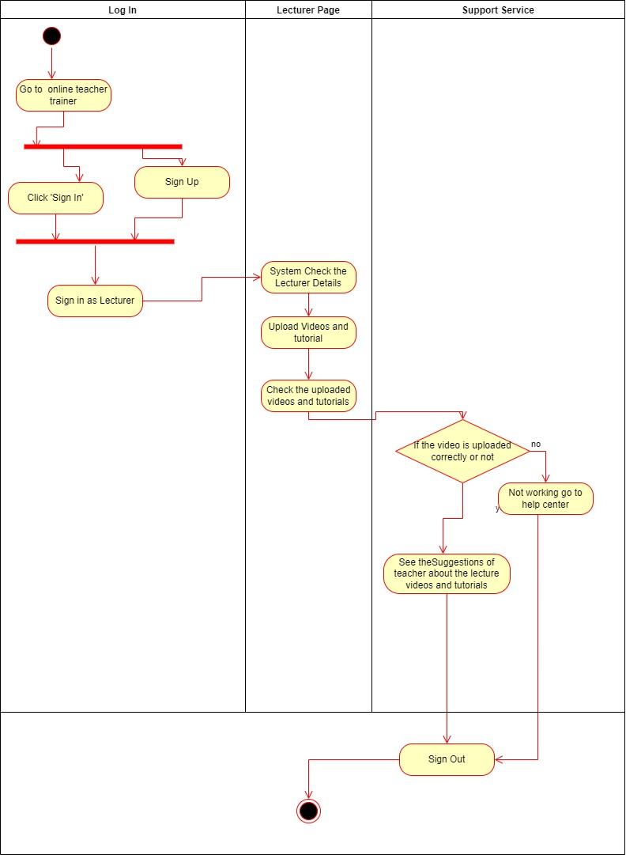

# Assignment 2 Cover Sheet

|  |  |
| --- | --- |
| **CASE STUDY NAME** | Online Teacher trainer |
| **PROJECT ID** | MLB 02.01.12 |

Group Details:

|  |  |  |
| --- | --- | --- |
|  | **Student Registration Number** | **Student Name** |
| **1** | IT21819506 | V.Abilaxshan |
| **2** | IT21828898 | S.Thusithan |
| **3** | IT21598500 | Abiramy.k |
| **4** | IT21809460 | M.Lavanya |

IT1060 – Software Process Modeling 2022 - July

# Assignment 2 Certify Sheet



I hereby certify,

The attached is my own work and no further changes will be made. I have contributed in this assignment to the best of my ability.

And I understand,

I may be subject to student discipline processes in the event of an act of academic misconduct by me including an act of plagiarism or cheating.

Student Details:

|  |  |  |  |
| --- | --- | --- | --- |
| **Student Name** | **Student Registration** | **Date** | **Signature** |
| **Number** |
| Abiramy.k | IT21598500 | 04.11.2022 | K.Abiramy |

|  |  |  |
| --- | --- | --- |
| **Number** | OTT2 | |
| **Name** | Create Report | |
| **Summary** | Create the annual report for the company | |
| **Priority** | 5 | |
| **Preconditions** | Enter in to the Database | |
| **Post conditions** | Successfully Create the report | |
| **Primary Actor (s)** | Manager | |
| **Trigger** | Decide to create report using user’s data | |
| **Main Scenario** | **Step** | **Action** |
|  | **1** | Login to the database |
| **2** | Enter in to the User Data Folder |
| **3** | Gather all user data files |
| **4** | Manager send user data to Staff to categorize the data according to the job title |
| **5** | Then, Manager send categorized data to the Assistant |
| **6** | Assistant return the created charts and graphs to the Manager |
| **7** | Till the Manager satisfied, Assistant modifies the charts and graphs |
| **8** | Once the manager satisfied, Manager create report |
| **9** | Manager add content, context and meaning to the report |
| **10** | Manager check the final report |
| **11** | Once the Manager satisfied with the report, Manager send the final annual report to the Admin |
| **12** | Admin publish the annual report which received from Manager |
| **Extensions** | **1a** | System asks to enter username and password |
|  | **1b** | System asks to reenter the password, if the password is incorrect |
| **2a** | System will display “Empty Folder”, if the folder is empty |
| **9a** | System will display “Enable editing” prompt |
| **11a** | System will ask “Enter Email address” to send the report |
| **12a** | System will ask “Do you want to publish?” when update the report |

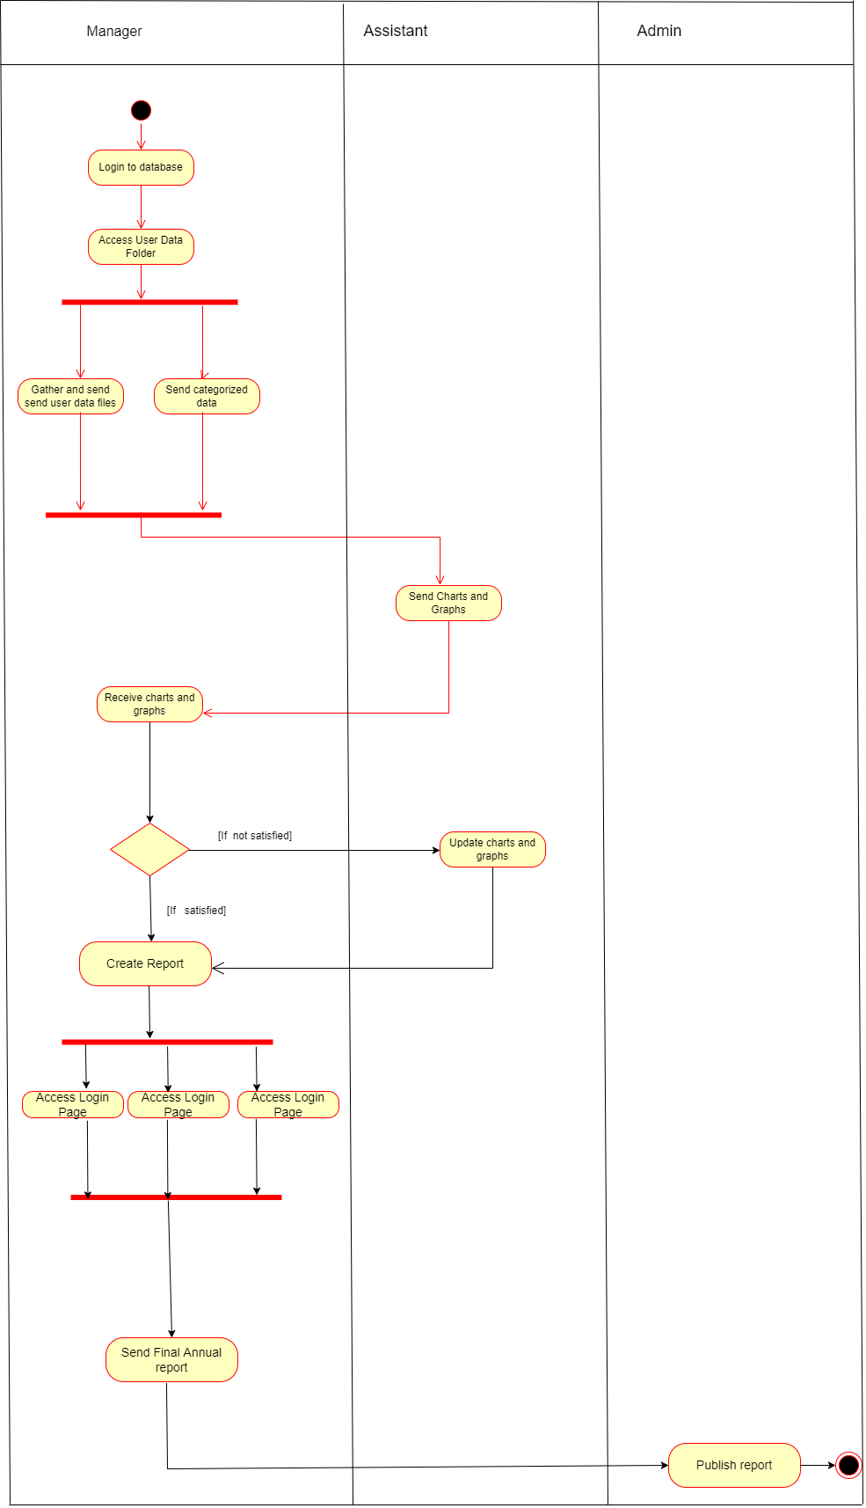

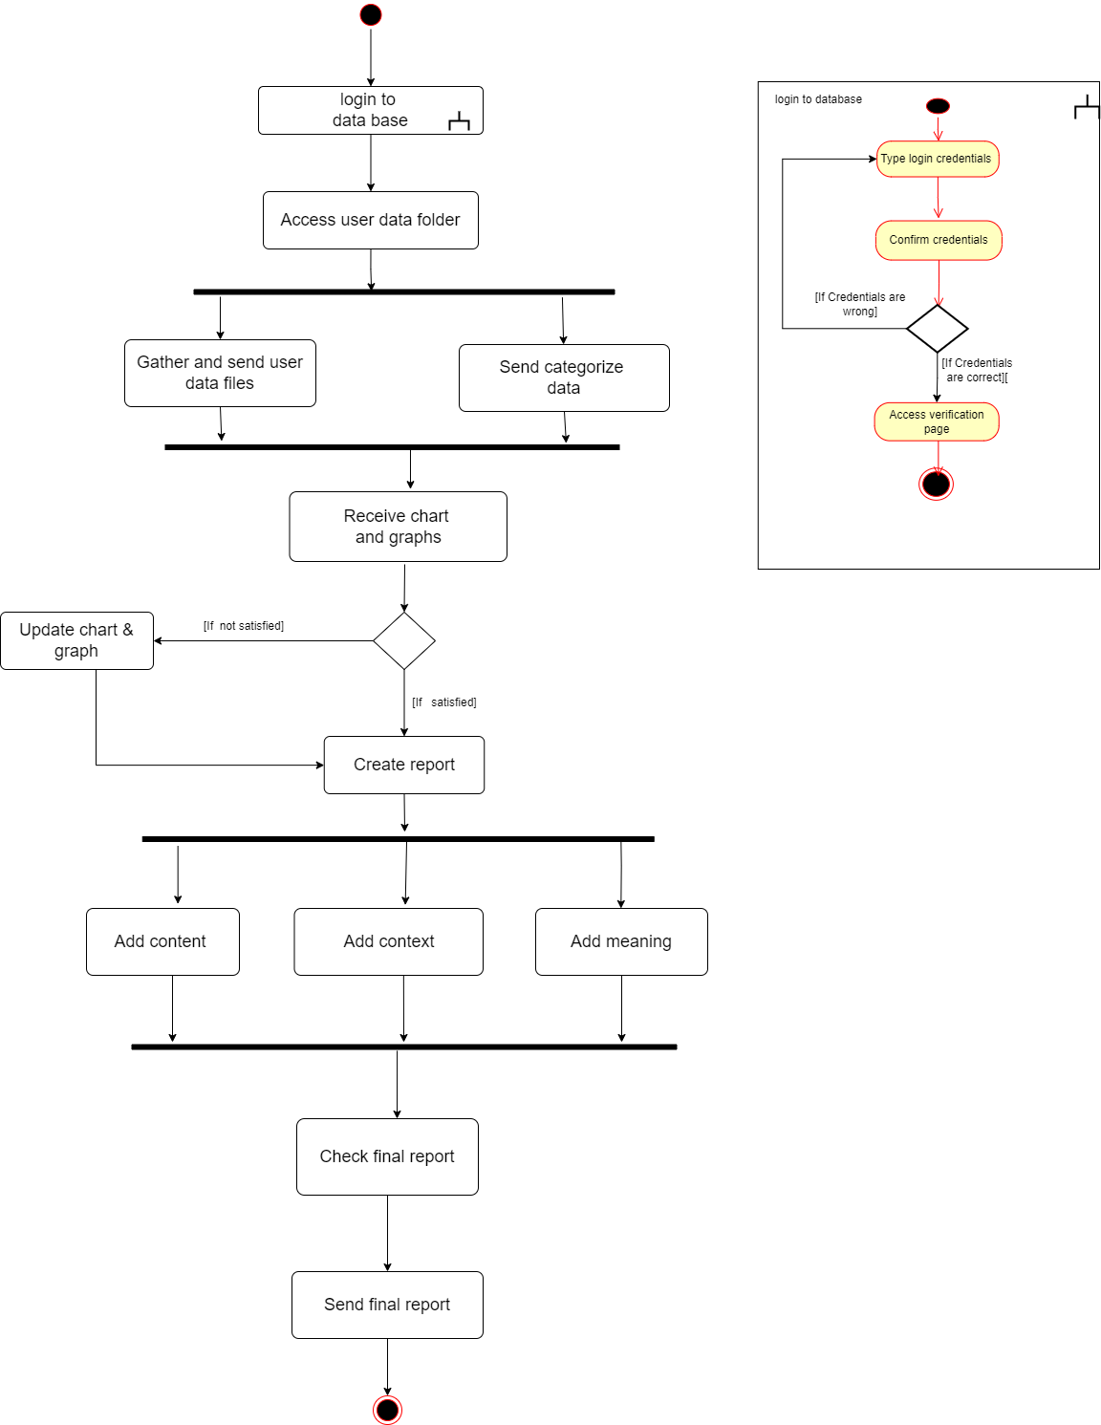

# Assignment 2 Cover Sheet

|  |  |
| --- | --- |
| **CASE STUDY NAME** | Online Teacher trainer |
| **PROJECT ID** | MLB 02.01.12 |

Group Details:

|  |  |  |
| --- | --- | --- |
|  | **Student Registration Number** | **Student Name** |
| **1** | IT21819506 | V.Abilaxshan |
| **2** | IT21828898 | S.Thusithan |
| **3** | IT21598500 | Abiramy.k |
| **4** | IT21809460 | M.Lavanya |

IT1060 – Software Process Modeling 2022 - July

# Assignment 2 Certify Sheet



I hereby certify,

The attached is my own work and no further changes will be made. I have contributed in this assignment to the best of my ability.

And I understand,

I may be subject to student discipline processes in the event of an act of academic misconduct by me including an act of plagiarism or cheating.

Student Details:

|  |  |  |  |
| --- | --- | --- | --- |
| **Student Name** | **Student Registration** | **Date** | **Signature** |
| **Number** |
| M.Lavanya | IT21809460 | 04.11.2022 | M.Lavanya |

|  |  |
| --- | --- |
| Number | OTT5 |
| Name | Register |
| Summary | User create new account |
| Priority | 1 |
| Pre-condition | The user is on the home page or on any page of the Online Teacher Trainer website |
| Post-condition | User register a new account |
| Primary Actor | Unregistered user(unregister teacher) |
| Main Scenario | |  |  | | --- | --- | | Step | Action | | 1 | Go to the online teacher trainer  (show the home page) | | 2 | Click on’Sign up’ icon on the web page | | 3 | The system redirects the user to the registration page | | 4 | Enter the following information on the webpage as required by the user.   * First name * Last name * Email * Phone number * Password | | 5 | Agree to the term & condition | | 6 | User click on submit form button | | 7 | An email will be sent to you, please follow the instruction on the e-mail and activate your account | | 8 | Open the user confirmation email and click the activation link | | 9 | User is redirected to a new page. the following message will be displayed” your account has been activated successfully” | |
| Extension | |  |  | | --- | --- | | Step | Branching Action | | 4a | If the username and password are already in use, a system will display a message and prompt the user to enter another username and password. | | 4a | The user did not fill in the required fields. System highlights show empty fields in red color and the following message.  "Fill Required Fields" | | 4c | If the invalid email address is given, display an error message to “This email address is invalid. Please enter a valid email address.” | | 5a | The user does not accept the terms and conditions. The system displays the following message.  "Please accept the terms and conditions". | | 7a | The user email was not received. Click on User "Click here to send an email." | | 8a | The activation link has expired because the user is taking too long. The user is redirected to a new page and the following message is displayed. “Your activation link has expired. Please request a new connection here. | |

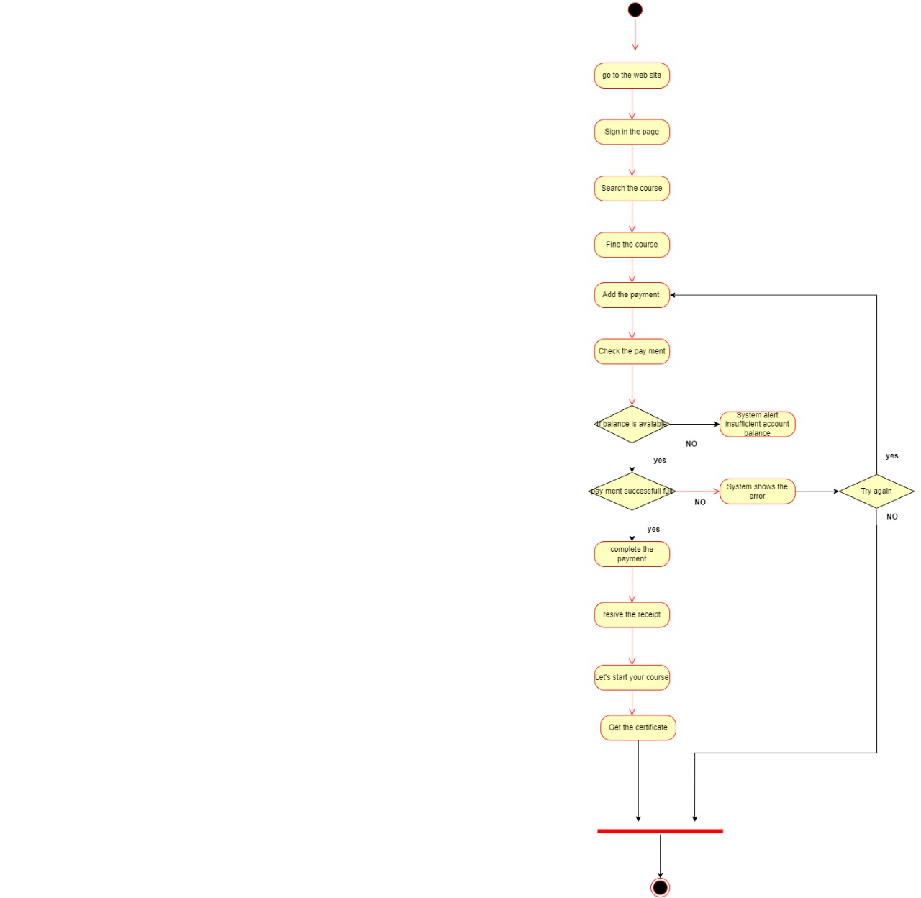

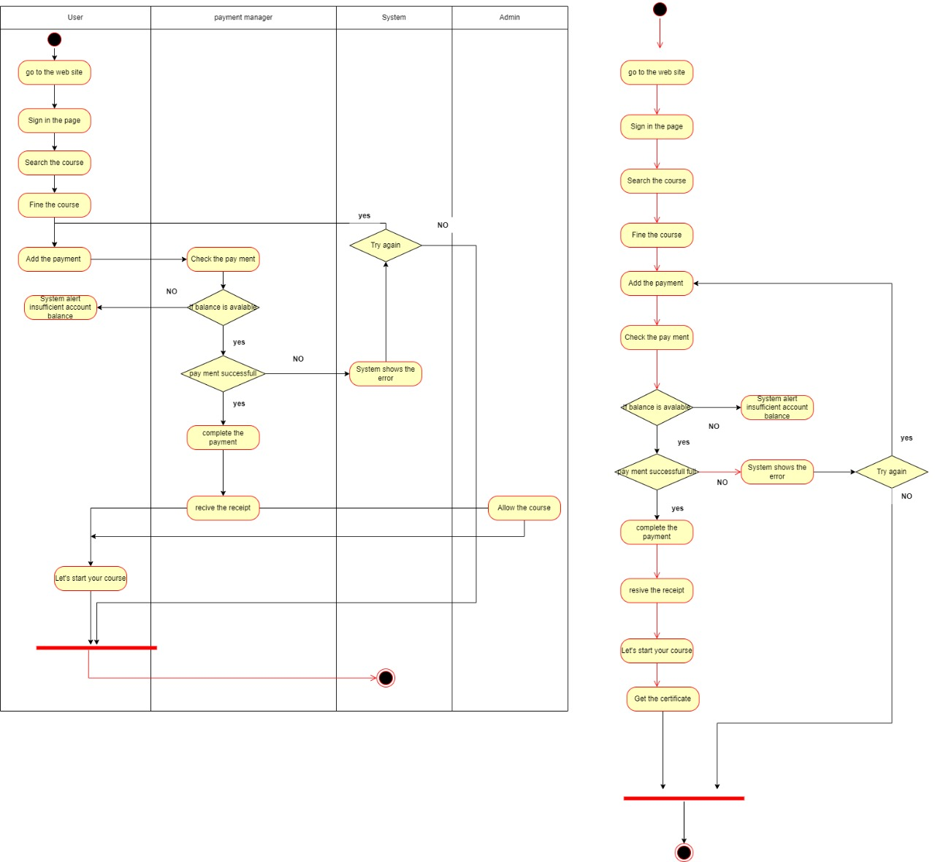

* Sub systems

a)user management

* Sign in
* Search the course
* Fine the course

b)Payment management

* Add the payment
* Complete the payment

c)System

* Syste shows the error

D.Admin

* Allow the course

**Level 2**

a) User Management

* Update User Details

1. b) manager

* Manage the payment details

1. c) System Management

* contact us
* Manager
* Owner
* Computer

d)Admin

• Access the courses